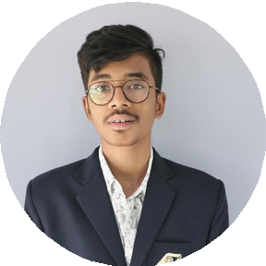BALAJI E

+91 6385497052

[balajie24@karunya.edu.in](mailto:balajie24@karunya.edu.in)

21/12 SV.Colony east 6th street PN road

partner.soddev.in/rb2/

TIRUPPUR 641602

# SUMMARY

Result-oriented Computer Science Engineering student with a strong passion for programming and software development. Skilled in various programming languages and technologies, I excel in problem-solving and creating efficient solutions. . I am always eager to learn new skills and take on new challenges, aiming to make a positive impact in the tech industry.

# EDUCATION

## SCHOOLING

**Sri Sai matric Higher Secondary School**

## 2009-2024

**BACHELOR DEGREE Karunya Institute of Technology and Sciences ** **2024-2028**

# CERTIFICATIONS

## GREAT LEARNING

 Introduction to cybersecurity

 Introduction to C Programming

## SIMPLILEARN

 C Programming basics

## LETS UPGRADE

**CISCO**

Programming with C

## HACKERRANK

C Essentials Part 1 & Part 2

cybersecurity and ethical haking bootcamp

# ADDITIONAL INFORMATION

**Technical Skills :** Project management,Group discussion,content creation,time mangaement,communication skills content creation,photo/video editing and more

**Programming Languages :** C,Python,basics in full stack development (MERN stack)

**Hobbies :** Games(cricket,badminton),editing,programming,cleaning and more

**Languages :**

TAMIL ENGLISH HINDI

KANNADA

100%

95%

65%

50%

THANK YOU